Name: _______________________
Evidence for Evolution
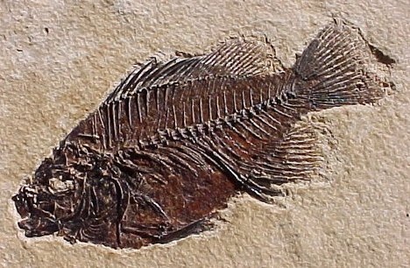
1.__________________________

Very old fossils are ________________, newer fossils are ___________________. This supports the idea of evolution because______________________________________________________________________________________________________________________________________________________

The number of ______________ that live on earth has also increased with time. Another word for the number of species is ______________________. This supports evolution because______________________________________
________________________________________________________________________________________________________________________________
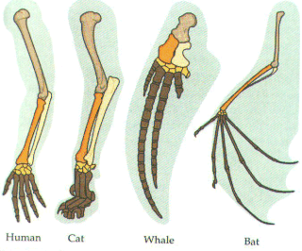
__________________________ are fossils that show species that seem to be a mix of an older and a new species. This suggests one species changing into another.
2.__________________________
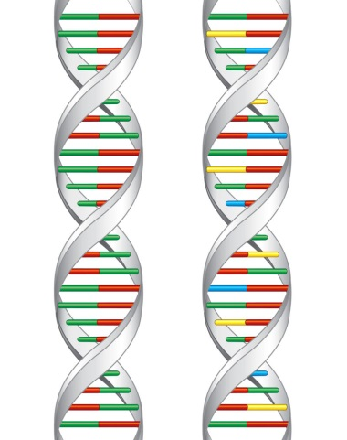
The compares the _______________ of organisms of both living and _______________. Homologous structures fit into this category. These suggest a common _____________________

3._____________________________________________
All living cells have the same basic _________ structure.

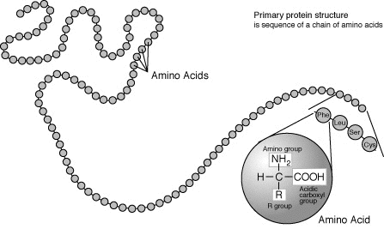
4.__________________________________
All species use the same _________ ______ to make proteins. Species that are more closely related have a more similar ___________________________ than species that are less closely related.

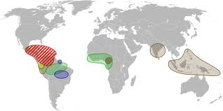
5.____________________________
Distribution is __________________________________________________________________________________________
Many __________ (not found anywhere else) species are found on isolated islands. With evolution you would expect this because ______________ is needed before __________________ can occur.

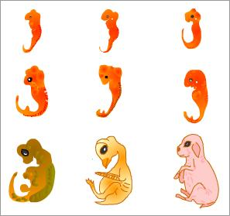
6.____________________________
This is the study of ________________________________________________________________________________________________.
All vertebrates are very similar when in the _____________ stage. The similarities include ________________________________________________________________________________________________________________________________________________________________.
The study of embryology supports the idea that species were formed from pre-existing species eg ___________________ evolved into________________ which evolved into ____________________________.

